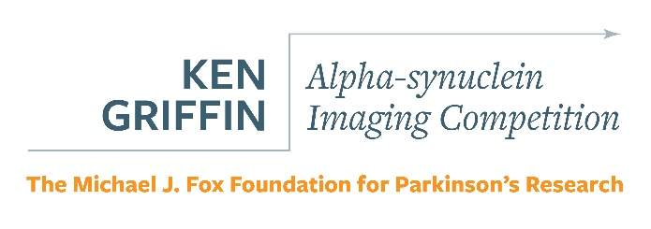

RFA Overview

BACKGROUND
Parkinson’s disease (PD) affects nearly 1 million people in the US and over 6 million worldwide, and those numbers are expected to rise over the coming decades. PD is highly heterogeneous: individuals experience a wide array of motor and non-motor symptoms, many of which depend on disease severity and duration. Though our understanding of PD and its causes is growing, many questions remain. Currently, there are no drugs available to slow or stop Parkinson’s progression while standard symptomatic treatments provide some limited relief but come with complications and side effects.

The Michael J. Fox Foundation (MJFF) funds research to define, measure and treat Parkinson’s disease as well as critical tools and other resources to advance that research. The purpose of this Request for Applications (RFA) is to develop imaging markers for utilization in clinical trials.

PROGRAM GOAL
The Ken Griffin Alpha-synuclein Imaging Competition seeks to accelerate work to develop a selective alpha-synuclein PET tracer. The ability to image alpha-synuclein deposition in the brain would be a game-changing achievement for the Parkinson’s disease (PD) field. The accumulation of aggregated alpha-synuclein is a pathological hallmark of PD and a priority target for drug development given its hypothesized contribution to neurodegeneration. In vivo imaging of alpha-synuclein pathology could be useful as a biomarker of the presence of disease and disease progression and as a pharmacodynamic tool for drug development. MJFF has prioritized alpha-synuclein imaging as the most likely imaging approach to have an impact for therapeutic development. The rationale behind this is that imaging the key pathology of PD would be the most direct and hopefully most sensitive means of measuring the progression of disease and therapeutics that alter the progression, especially those that target alpha-synuclein directly.

PROGRAM PRIORITIES
MJFF encourages multidisciplinary teams to apply to this program and is particularly interested in collaborations between academic and industry groups that have access to diverse compound libraries. Projects can include compound screening, tissue binding studies, lead identification and optimization, in vivo testing in appropriate animal models, and first-in-human testing of candidate tracers. Funding prioritization will be given to those teams that show the greatest promise for delivering a selective tracer for human testing at the end of the funding period.

DEADLINES & REVIEW SCHEDULE
Proposals Due: January 17, 2020
Anticipated Award Announcement: March 2020
Anticipated Funding: April 2020

FUNDING AVAILABLE
Duration: One- to two-year grants
Award Amount: The total amount of funding available for this program is $10 million. A total of $8.5 million is available for the first two years of the program with the possibility of an additional $1.5 million for the project that shows the most promising results during the initial funding period. These budgets include direct and indirect costs. For academic and for-profit institutions, no more than 25% or 10%, respectively, may go to indirect costs. Additional details about MJFF's indirect cost policy can be found in the Administrative Guidelines and FAQ.

ELIGIBILITY REQUIREMENTS
Applications may be submitted by researchers or clinicians in:
- U.S. and non-U.S. biotechnology/pharmaceutical companies, or other publicly or privately held for-profit entities; and
- U.S. and non-U.S. public and private non-profit entities, such as universities, colleges, hospitals, laboratories, units of state and local governments and eligible agencies of the federal government.
- Post-doctoral fellows are not eligible to apply as principal investigators.

As imaging programs may require many kinds of expertise, MJFF encourages industry and academic collaborations when appropriate.

ADDITIONAL INFORMATION
Our Administrative Guidelines provide general guidance about applying for funding from MJFF. Please note that the RFA always supersedes information contained in the Administrative Guidelines.

MJFF will host an informational webinar on October 10, 2019 at 12 p.m. ET to clarify and explain the goals of our funding opportunities and answer applicant questions. The webinar will also be available to view on-demand after the live airdate. To register, please clickthrough to this RFA webpage from our Funding Opportunities webpage.

