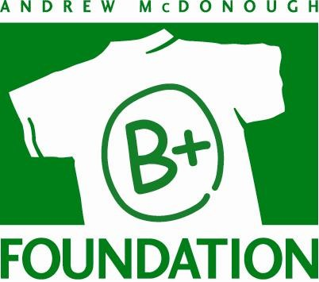

The Andrew McDonough B+ Foundation
Childhood Cancer Research Grant Process

The Andrew McDonough B+ (Be Positive) Foundation (www.BePositive.org) is the largest provider of financial assistance to families of kids with cancer nationwide.

Additionally, The B+ Foundation, with the help of a highly respected Scientific Advisory Board, funds cutting-edge childhood cancer research. The B+ Foundation funds grants that support basic, translational or clinical research, which may lead towards cures and better treatments for childhood cancers.

The 2020 Research Grant Cycle is open on proposalCENTRAL from June 1- Sept 11, 2020.

Five to ten grants will be awarded. Each grant will be a 2 year grant of $75,000/yr for a total grant award of $150,000. Eligibility criteria includes:

- Applicants must have a M.D., D.O., Ph.D, or PharmD degree
- Applicants may be Assistant, Associate or Professor level investigators
- Applications will be considered from instructors who have a minimum of a two-year commitment from an accredited academic institution

CONTENT OF APPLICATION

- Contact information
- Lay summary (1/2 page)
- Research proposal (4 pages maximum)
  - Abstract
  - Hypothesis and Specific aims
  - Background and rationale
  - Approach/methods
  - Expected results/challenges
  - Significance
- References (2 pages max)
- Budget (1 page)
(The B+ Foundation does not cover indirect costs)
- Budget Justification (1 page)
- Institutional Resources (1 page)
Address relevant access to laboratory, clinical, animal, computer, office resources, need to complete your research, if applicable
- Biosketch in NIH format
- Other grant support (current, pending, and past 3 years)
- Letter of support from Division Chief or Department Chair

AWARD GUIDELINES

- All research must be directly related to pediatric cancer.
- Research proposals will be evaluated based upon:
  - Quality of science including impact on field
  - Innovation
  - Quality of applicant
  - Institutional environment
  - Appropriateness of budget
- Selected grant recipients give The B+ Foundation permission to use Applicant’s logo, images, photos, and posting of research proposal title and results as the charity sees fit.
- Submission of the application does not entitle Applicant to an award. The B+ Foundation reserves the right to select grant recipients at its sole discretion.

